DNS and DNS SERVERS

The Domain Name System (DNS) is a naming system for computers systems that are connected to the Internet or a private network. It translates more readily memorized domain names to the numerical IP addresses needed for locating and identifying computer services and devices with the underlying network protocols.
It defines the DNS protocol, a detailed specification of the data structures and data communication exchanges used in the DNS. An often-used analogy to explain the Domain Name System is that it serves as the phone book for the Internet by translating human-friendly computer hostnames into IP addresses. For example, www.google.com is mapped to the IP address 172.217.20.68.
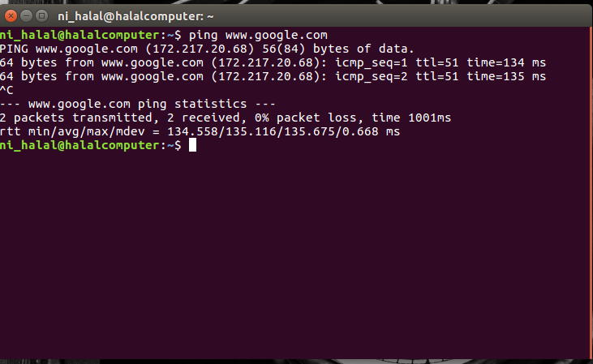
An important function of DNS is its central role in distributed Internet services such as cloud services . When a user accesses a distributed Internet service using a URL, the domain name of the URL is translated to the IP address of a server that is close to the user. The key functionality of DNS exploited here is that different users can simultaneously receive different translations for the same domain name!

A DNS server is a computer server that contains a database of public IP addresses and their associated hostnames, and in most cases, serves to resolve, or translate, those common names to IP addresses as requested. We have DNS servers because we not only want to use human-readable names to access websites, but the computers need to use IP addresses to access websites. The DNS server is that translator between the hostname and IP address.

The DNS server settings "closest" to the device are the ones applied to it. For example, while your ISP might use one set of DNS servers that apply to all the routers connected to it, your router could use a different set which would apply the DNS server settings to all the devices connected to the router. However, a computer connected to the router can use it's own DNS server settings to override the ones set by both the router and the ISP.

nslookup command helps us find the IP address(es) corressponding to the domain name typed in by us.

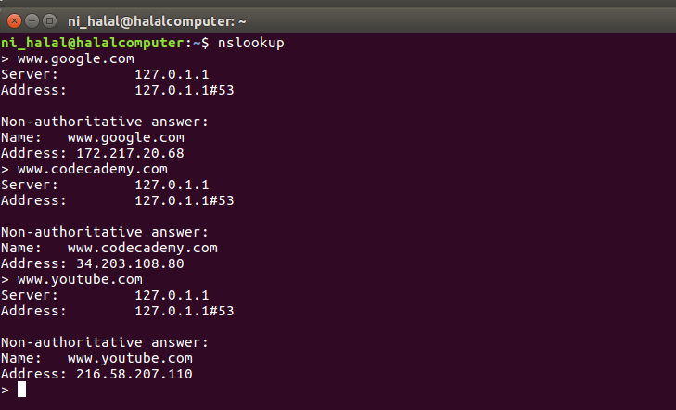

There are a number of DNS servers located within the connection of computers that we call the internet. Most important are 13 DNS root servers that store a complete database of domain names and their associated public IP addresses.
These top-tier DNS servers are named A through M for the first 13 letters of the alphabet. Ten of these servers are in the US, one in London, one in Stockholm, and one in Japan.

By
Nihal Haneef
16CO128

